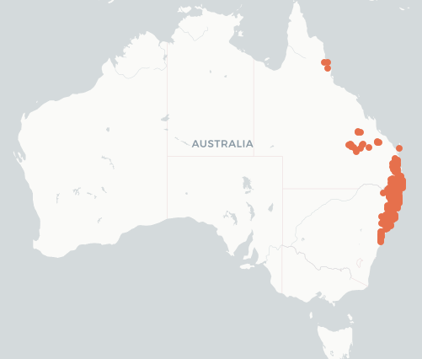
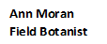
Lobeliaceae
Lobelia trigonocaulis
forest lobelia

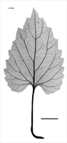

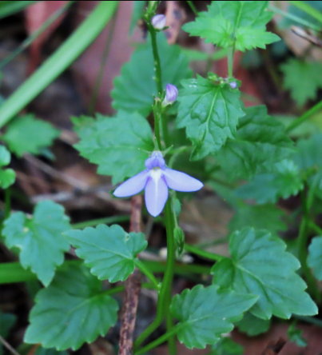

ALA Local Natives

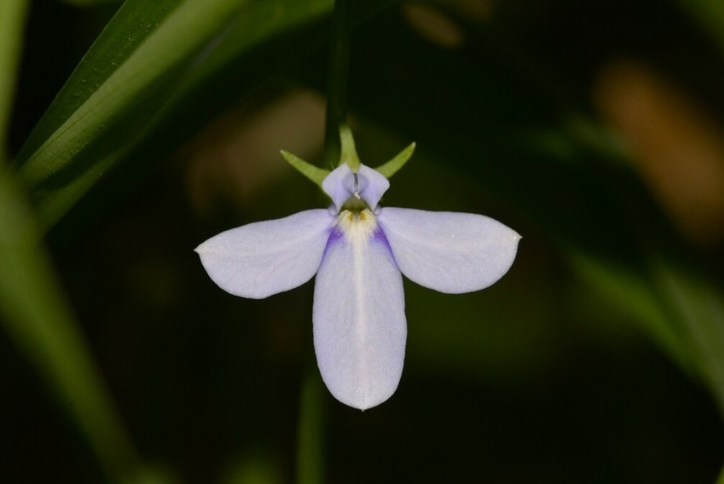
roserobin

Nick Lambert

ETYMOLOGY (lo-BEEL-ee-a) After Mathias de l'Obel 1538-1616 Flemish botanist; The species
trigonocaulis = three-angled stems;
LIFEFORM Creeper 30-60 cm x 1m spread
STATUS Sheltered moist situations Qld, NSW; Southern geographical limit Ourimbah (Harden
1992); Recorded @ >180 Locations (Moran, A 2009)
OCCURS Maroochy Botanic Gardens, Blackdown Tableland Q, NSW
HABITAT Trackside, Swamp, Creekside, Palm forests, Dry Rainforest
LEAVES Alternate, 1-4 x 3.5 cm, ovate to heart-shaped with scalloped to bluntly toothed edges and
pointed tip, with milky sap on weak triangular stems
FLOWERS Blue, 15 mm, mauve split to base 3 lower lobes broader than upper 2; Calyx persistent
corolla irregular; in loose 3-6 flowered terminal racemes each flower has 5 spreading
irregular lobes with 3 oblong lower lobes + 2 much shorter upper lobes;
Flowering Times Dec, Jan, Feb, March, April, May
FRUIT Capsules, 3.5-5 mm, globose, scarcely oblique with 1 mm seeds;
Fruiting Times Dec, Jan, Feb, March, April, May
ROOTS Roots from the nodes
STEM Sparsely hairy creeping trailing herb prostrate sparsely hairy with flattened trailing 3 angled
stems;
ETHNOBOTANY Useful basket specimen, groundcover; Plant contains Lobeline and related alkaloids in
some degree; Shady wet, sclerophyll forests; Need plenty of water and heavy shade;
INSECTS Cosmodes elegans (Moth)70
ID FEATURE Stems decumbent, flowering shoots ascending + Leaves ovate, base of lamina truncate to
cordate; Leaves and stems hairy; Leaves with crenate margins and cordate base; pedicels
3-7 mm long

