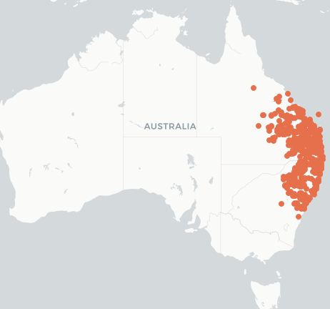

Mimosaceae
Acacia leiocalyx subsp. leiocalyx
early-flowering wattle
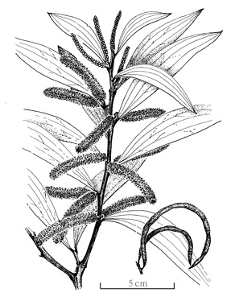
ALA Local Natives
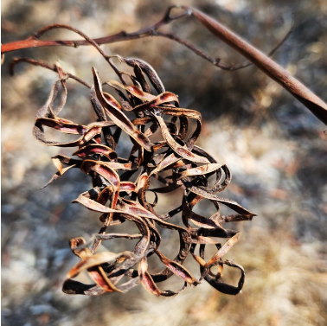
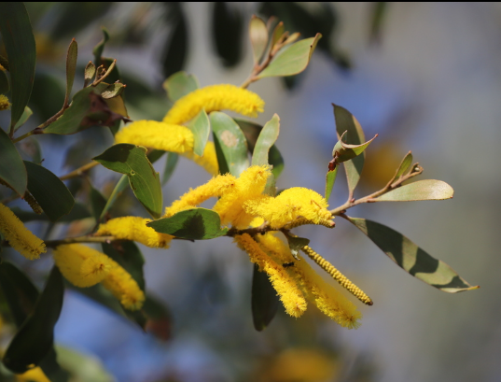
Arthur Chapman iNat
Darren Fielder iNat

ETYMOLOGY (a-KAY-sha) Greek akakia from akis = a sharp point; The species leiocalyx (lee-oh-CAY-lix) = smooth calyx;
LIFEFORM Tree 4-6m x 2m Spread
STATUS Widespread in Eastern Qld, where it extends from S of Mackay Northern Limit Gladstone (inland to about 146° E) to northeastern New South Wales; also Sydney and Narrabri
OCCURS Burdekin Basin Qld to Taree NSW
QLD DISTRICTS Burnett, Darling Downs, Leichhardt, Maranoa, Mitchell, Moreton, Port Curtis, South Kennedy, Warrego, Wide Bay
HABITAT Coastal heaths, Open forest, Headlands, woodland
LEAVES Alternate, 8-15 cm x 7-30 mm, narrow elliptic flat, obliquely falcate acute to mucronate,
3 prominent veins, glabrous secondary veins are branching; rounded ends with red angular branches on 3-4 mm stalk.
FLOWERS Rod-shaped, 3-7 cm, yellow, scented, cylindrical spikes in pairs; sepals united with glabrous triangular lobes petals partly united reflexed and glabrous ovary woolly.
Flowering times April, May, June, July, Aug, Sept, Oct
FRUIT Pods, 7-15 cm, loosely straight open coiled, convex over seeds cylindrical narrow drying to dark brown; seeds longitudinal in pod stalks (funicles) folded several times below the seed and terminating in orange aril; Fruiting times Oct, Nov, Dec
BARK Deeply fissured greyish brown, slightly furrowed, develop uneven cracks; Vegetative spread: Possibly root suckering
STEM Shrub to small tree; Branchlets sharply 3 angled glabrous, reddish brown flattened towards apices, lenticellate, glabrous short stout stem
ETHNOBOTANY Edible seeds and gum; wood for cabinets; Bark contains 9.13% Tannin; Cattle eat the leaves all year.
TOLERANCE: Full sun Heavy clay soils
WILDLIFE Food plant for squirrel gliders and sugar gliders Insects take nectar, rich in amino acids, from phyllode glands (Bernhardt 1982)
INSECTS Bethelium signiferum, Calomela crassicornis, Chrysolophus spectabilis Diamond Weevil, Eucerocoris tumidiceps (acacia bug) Cicadetta oldfieldi (inland wattle cicada) Lampromicra senator Metallic Shield bug Pachydissus sericus,
MISTLETOES Amyema quandang, Dendrophthoe glabrescens;
BIRD Thornbill, Bronze-wing Pigeon, Red-tailed Black-cockatoo
BUTTERFLY Hypochrysops delicia Moonlight Jewel, Jalmenus evagoras Comon Imperial Blue, Prosotas dubiosa, Prosotas felderi Small Tailed Lined-blue, Sahulana scintillata Glistening Line-blue, Prosotas dubiosa,Theclinesthes scintillata
INDIGENOUS USES Used in production of gum,seeds eaten, wood used to make boomerangs.
ID FEATURE Phyllodes inequilateral (lower margin ±straight, upper convex) broadly wedge-shaped on
3-4 mm stalks; Branchlets reddish triangular + Flowers yellow calyx without hairs in spikes
+ Pods thin curved Seeds with bright yellow aril.

