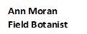
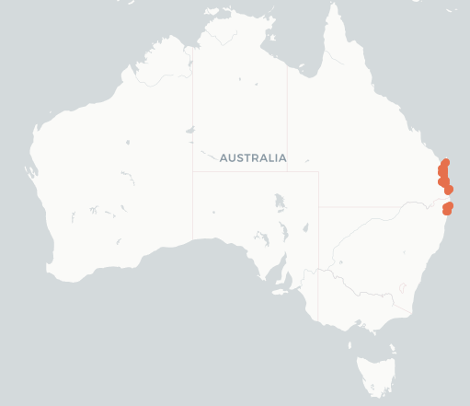
Myrtaceae
Leptospermum speciosum
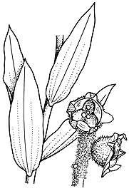
Swamp tea-tree

ALA Local Natives
ALA Local Natives

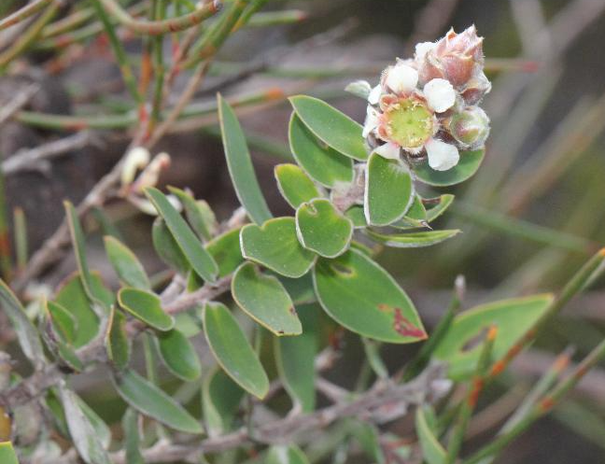
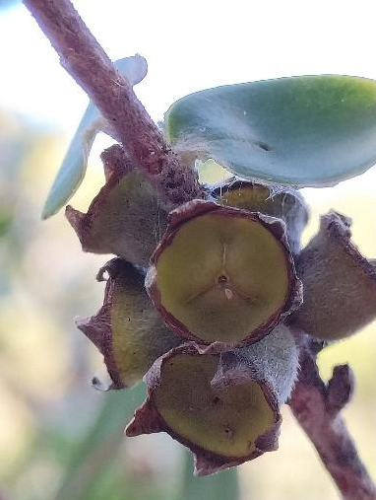

Liz Snow iNat
Pete Woodall iNat

ETYMOLOGY (lep-to-SPERM-um) Greek leptos = slender + sperma = seed; The species speciosum = showy beautiful
LIFEFORM 3m x 2m Shrub
ORIGIN Sunshine Coast, Fraser Island SE Q, Broadwater N P NSW
HABITAT Coastal Heathlands, Swamps
LEAVES Alternate, 1-3 x 1 cm sessile, on 1 mm petioles, apex sharply pointed, softly hairy when young.
FLOWERS Terminal, 3-4 mm, white 5 petals, clusters of >5 individuals, surrounded by hairy bracts. Flowering Times: Aug, Sept, Oct
FRUIT Capsules, 6 mm, broad, deciduous in terminal 3-5 cluster at branch ends.
Fruiting Times: Dec, Jan
BARK Flaky, peeling in strips smooth orange underneath.
TRUNK or STEM Erect with hairs branchlets.
ETHNOBOTANY Ornamental potential usage in landscaping.
PESTS Hemithynnus variabilis (flower wasp)
BUTTERFLY Butterflies feed on nectar
ID FEATURES Leaves <10cm long, base blunt or rounded + scented when crushed + Flower 5 petals + Capsules 6 mm wide, sides with silky hairs, top hairless, cup shaped.

