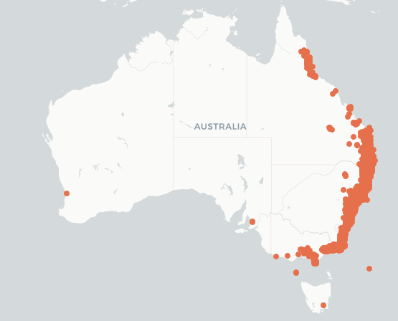
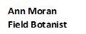
Myrtaceae
Syzygium smithii
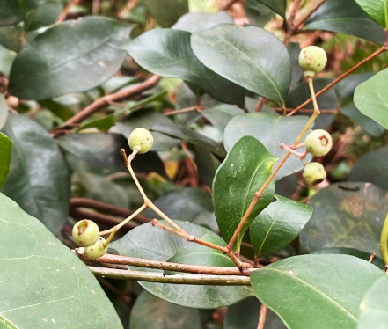
Was
Meygels iNat
Acmena smithii
Creek Lily-Pily

ALA Local Natives

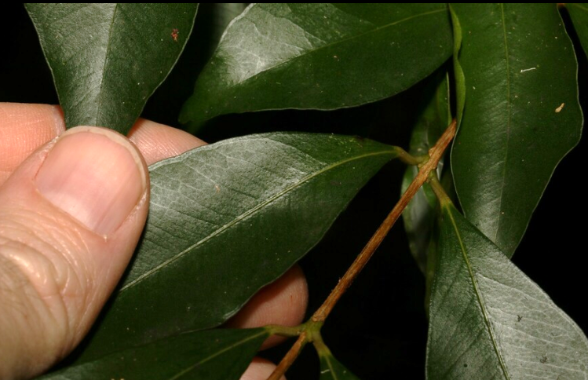
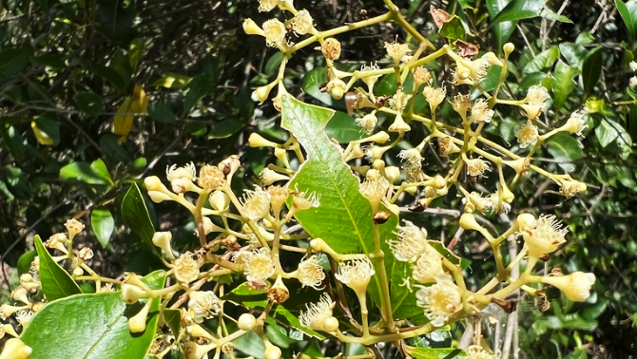

ccofficers iNat
Greg Tasney iNat
ETYMOLOGY (ac-ME-na) Greek acmenae = beautiful Nymph of Venus; The species smithii = After Sir James Edward Smith 1759-1828 English botanist.
LIFEFORM Tree 8-30 m x 5-9 m spread
STATUS Well conserved; from coast to mountains Qld, NSW, Vic.
OCCURS Windsor Tableland N Q, Sydney NSW, Wilsons Promontory, Vic
HABITAT Dry Rainforest, Subtropical Rainforest, Microphylla/Notophylla Vineforest
LEAVES Opposite, 5-8 x 2-4 cm, ovate, narrow-lanceolate to broad-ovate dark green, midrib sunken above, raised midrib below; lateral veins 65-80 degree, long blunt tip; obvious oil dots
FLOWERS Petals white, cream numerous fluffy stamens, 4 petals 4 sepals on short stalks in panicles; Flowering times Oct, Nov, Dec, Jan
FRUIT Drupes, 8-20 mm, firm with round apical cavity, white maybe tinged with purple; White/pink or mauve berry ripe; Fruiting Times Jan, Feb, March, April, May, June, July, Aug, Sept,
BARK Grey reddish-brown, scaly on lower trunk, smooth on upper trunk & branches.
TRUNK or STEM Tree with flattened trunk twisted branches; Reddish twigs; Branchlets smooth mostly with 4 prominent vertical ridges.
ETHNOBOTANY Good for jams; Hard light brown timber used for floors, and lining.
LANDSCAPE USES Attractive red-bronze new growth; ornamental potential usage in landscaping, container plant will clip into hedge; excellent dense windbreak; Terminal bunches of edible fruit which are white, pink/purple full of Vitamin C
TOLERANTS Tolerates drought, frost, wind and sea spray.
INSECTS Chinese & White Wax Scale, Eugenia Pimple Gall, Aenetus ligniveren,Aenetus ramsayi, Agriophara horridula, Cryptaspasma sordida, Cryptophasa pultenae Pultenaea Moth,Pholodes sinistraria frilled bark moth
WILDLIFE Fruit food plant for Qld Blossum Bat, Grey-headed Flying-fox; Attracts fruit-eating birds and nectar feeders such as honeyeaters
MISTLETOE Host plant for Amyema congener, Amylotheca dictyophleba;
BIRD Fruit Eaten by Topknot Pigeon, White-headed Pigeon, Superb fruit Dove, Wonga Pigeon, Rose-crowned Fruit-dove
BUTTERFLY Arhopala micale Common Oak blue, Chaetocneme beata Common Red-eye, Hypolycaena phorbas, Netrocoryne repanda Bronze Flat
ID FEATURE Acmena have sunken midribs; World has 15 species; Aust has 6 species undergoing reclassification to Syzygium;

