
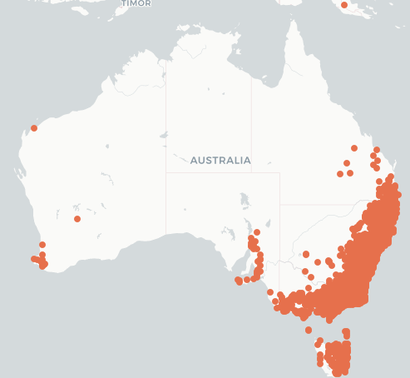
Poaceae
Echinopogon ovatus
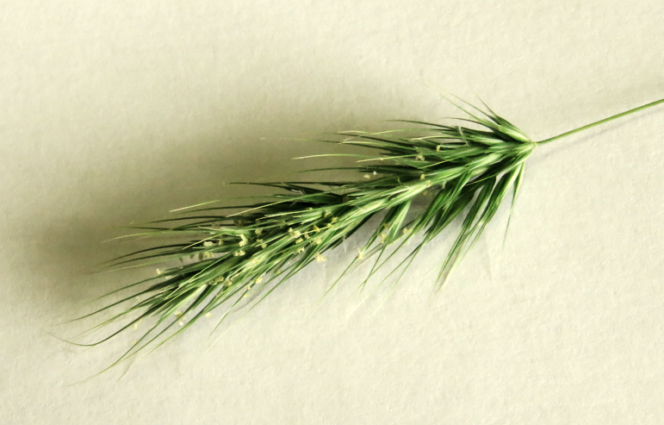
forest hedgehog grass
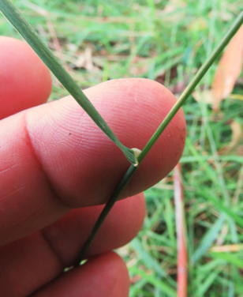
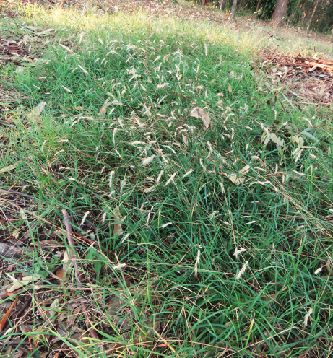
Mike Fox
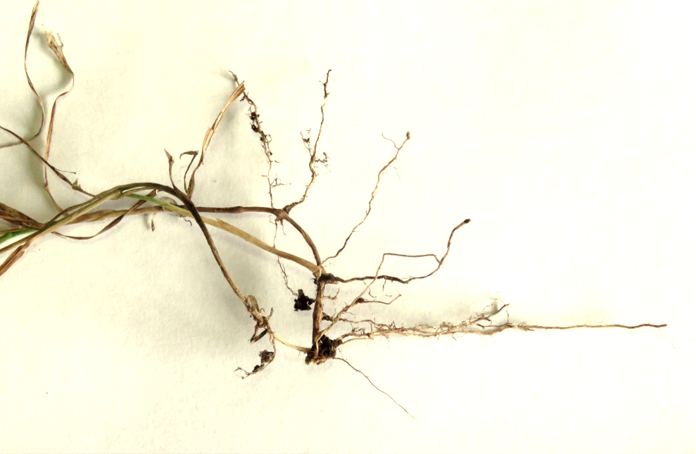
Mike Fox

Mike Fox
Rhizomatous roots
Mike Fox

ETYMOLOGY (ek-i-no-PO-gon) Greek echinos = hedgehog + pogon = beard referring to very rough awns; The species ovatus (o-VAH-tus) from Latin ovate ovum = egg + ata = possessing, Inflorescences, spikelets, or leaf-blades ovate in outline.
LIFEFORM Grass 15-100cm
STATUS Widely distributed in SE Australia Fairly common from Tropic of Capricorn south to Tas; All states except NT; Recorded from Margaret River near Nannup, from Lowden WA
OCCURS Mount Gravatt, Qld, NSW, Vic, SA, WA, Tas (NG, NZ)
QLD DISTRICTS Burnett, Cook, Darling Downs, Leichhardt, Moreton, North/South Kennedy, Port Curtis, Wide Bay
HABITAT Open forest/Woodland
LEAVES Blades 1.5-16 cm x 2-8.5 mm, spreading, recurved, linear, lanceolate, surface smooth or scaberulous, hairless (glabrous), margins scaberulous, apex acuminate.
FLOWERS Panicles, 2.5-4.5 mm, laterally compressed, oblong bristly spike-like, short spikelets & virtually entire lemma apex; Flowering times Oct, Nov, Dec, Jan
FRUIT Grains, 2.5 mm, ellipsoid, flattened apex shortly pilose;
Fruiting times Jan, Feb, March, April, May
LANDSCAPE USES Attractive plant in landscape, gardens
STEM Grass leaf-blades spreading or deflexed; Awns 4-15 mm; Stems 3-7 noded;
ROOTS Rhizomatous
BUTTERFLY Taractrocera papyria White-banded Grass Dart
ID FEATURE Confused with Setaria pumila (weed); Stems bent at base + Leaf-blades spreading or deflexed + Flower bear 5 cm, ovate, dense, awned spikelets stalk 3-7 noded + Spikelets excluding awns 2.5-5 mm;

